**2024-25 UIL Social Studies: An overview**

**TOPIC:** *The Rise of Factionalism, Partisanship and the “Vices of Democracy” in the early United States (1795-1850)*

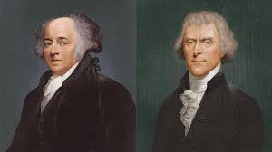 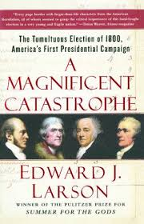

John Adams and Thomas Jefferson

**WHAT IS THE FORMAT OF THE EVENT?**

* 90 minutes in length
* 45 multiple choice questions
* 20 are general knowledge questions over the topic (1 point each)
* 15 are questions from the primary source material (2 points each)

**Primary source material:** *A Magnificent Catastrophe: The Tumultuous Election of 1800, America's First Presidential Campaign* by Edward J. Larson

* 10 are questions from the supplemental reading material (3 points each)

**The supplemental reading material and terms are provided on the UIL Social Studies page**

[**https://www.uiltexas.org/academics/academic-contests/social-studies**](https://www.uiltexas.org/academics/academic-contests/social-studies)

Click on 2024-25 Reading List (should be updated by the end of May 2024)

* Essay (worth up to 20 points)🡪**Entries with no essay are disqualified.**

**WHO MAKES THE UIL SOCIAL STUDIES TEAM?**

* **Four** students make the UIL Social Studies team for district competition.

**HOW DO I MAKE THE UIL SOCIAL STUDIES TEAM?**

* Demonstrated proficiency is the primary way to make the team. There will be opportunities to attend UIL invitational meets in the spring, and there will be opportunities to take practice tests during the fall. Those opportunities will be established by the social studies coach in conjunction with willing participants.
* Read, read, read, and then read some more. March and April success stories are written in the fall.

**WHY SHOULD I DO THIS?**

* Scholarship eligibility potential: Any student who qualifies for UIL State competition in an academic event at any point during high school is eligible to apply for TILF scholarships.