**School Dude Campus Administrator Guide**

1. School Dude Campus Administrator will create a Building Use Request Read Only Shared Calendar on Outlook and will provide access to the staff.

(Please refer to **How to Set up a shared Calendar in Outlook** Word documentfor assistance)

1. Requesters will first look at the Calendar and see if there are events already planned on their intended dates/times or if the space they have planned on using is already occupied.
2. After ensuring the availability, Requesters will then email **New Schedule Request Form** to the School Dude Focal Point. (Snapshot attached)

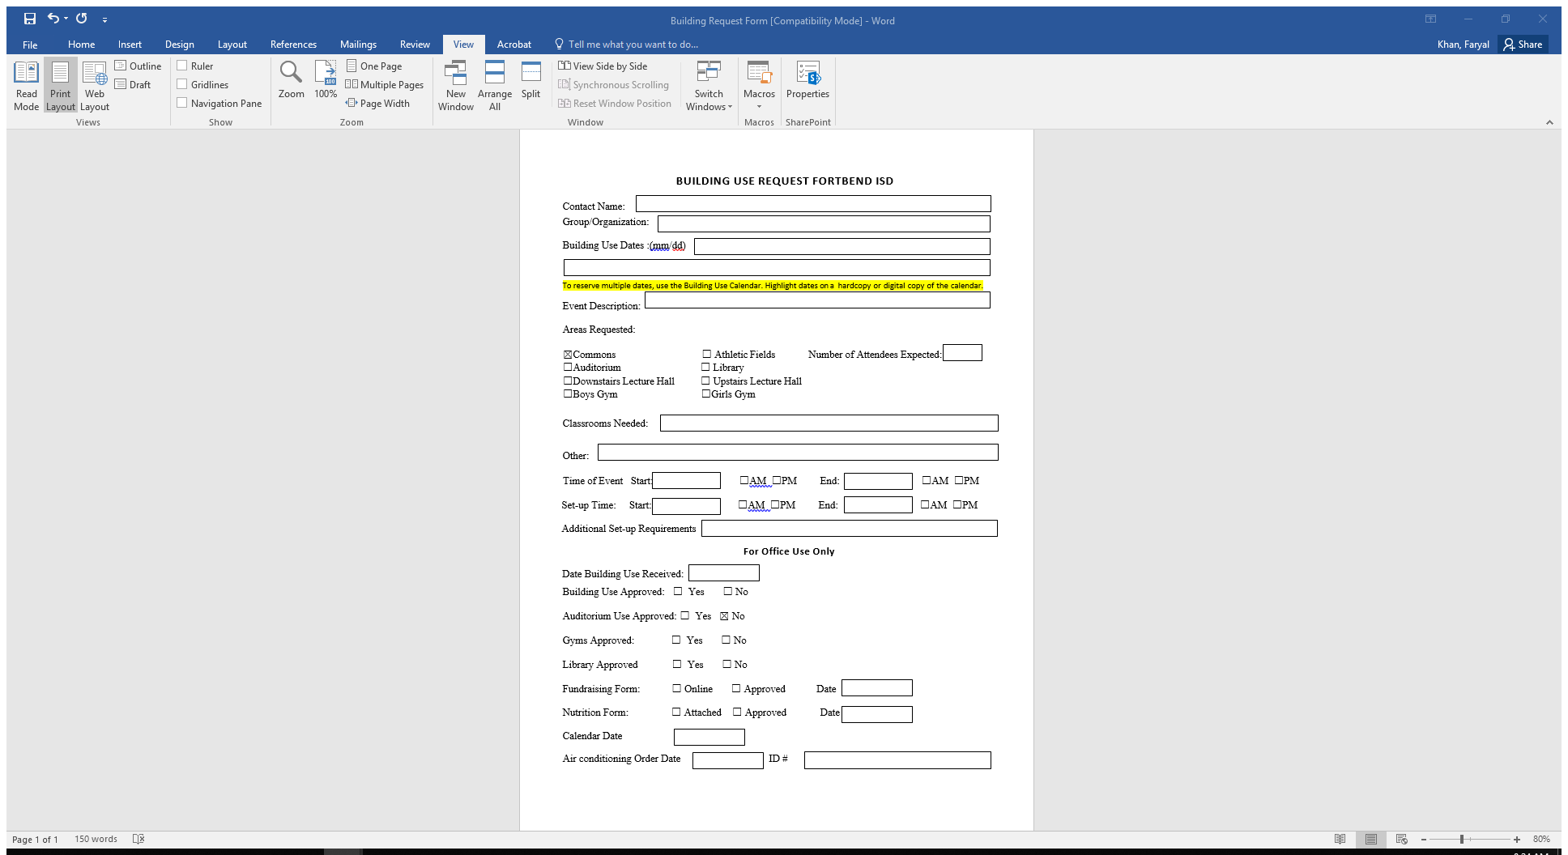

1. The School Dude Administrator will double check if the desired slot is available (If the request is already there for the specified time/date/space).
   1. If yes, he/she will notify the requester.
   2. If not, the person will enter the event in the Calendar.
2. The Administrator will create the request on School Dude and will wait for the approval. The requests must be created at least 48 hours before the event for timely processing.
3. On approval, the Focal Point will copy the unique Schedule ID # from School Dude and may enters it against that event’s details on spreadsheet to maintain a record for future use.

