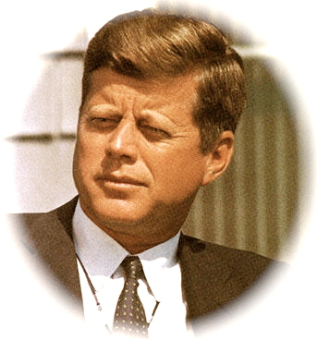

**1960’s Research Project**

**Objective**: For students to research various aspects of American culture and politics during the time of The Outsiders, the 1960s. Students will present their information in a group newsletter from the time period.

**Directions**:

1. Students will work in groups of 3-4.
2. Each group member will select 2 aspect(s) of their era (see topics below) to research
3. Each project should include information on the following:

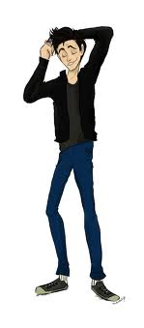

* 1. Fashion/Clothing/Hairstyles (men and women)
  2. Food
  3. Music
  4. Entertainment/Recreation/Leisure
  5. Values (Culture, what was important, slang, etc.)
  6. Politics and Leaders
  7. Inventions, technology

1. This project should provide the readers with an overall idea of what happened during that decade and what it would be like to live during that time period.
2. After researching the topic, students will need to compile their information in a newsletter or magazine format.

**Project requirements**:

1. Research at least 3 different sources per student (websites, books, interviews) are used for researching the decade
2. Present information about the 1960s in the form of a newsletter or magazine
3. Each student needs to create 2 pieces for the newsletter.

**Presentation Aspect of Project**

1. Create a newsletter or magazine to display your information that you researched
2. You must include the following pieces in your magazine. You can determine which information to present in the different formats.
   1. 2 articles
   2. 1 original advertisement (made by you!)
   3. 2 mock interviews
   4. 1 review (of a concert, sporting event, etc)
3. Use pictures, word art, fun fonts, etc.
4. Include a TYPED bibliography (MLA)
5. Include a typed list of all group members and what each group member was responsible for
6. Have fun and be creative!

**Research and Data (must use at least 3 sources to answer the questions below)**

1. Fashion
   1. What type of clothing was popular during that time period?
   2. Popular accessories?
   3. Popular hairstyles?
   4. Make sure to illustrate difference between Men and Women and also social classes
2. Music
   1. What type music was popular during that time period?
   2. What musicians were popular?
   3. Try to find specific examples that could be listened to in class
3. Recreation/Leisure
   1. What venue was used for entertainment? (movies, music, television, sports, etc)
   2. Popular activities (dances, games)
   3. Any popular movie stars, sports figures
4. Food
   1. What was the American diet like?
   2. Popular restaurants and/or meal?
   3. Usually cook at home or dine out?
5. Politics
   1. Who were the presidents during the decade?
   2. Any political scandals?
   3. Any wars?
6. Values/culture
   1. What was important to the American people during that time period?
   2. How did they view women? People of color?
   3. Were there any movements or revolutions during that time period?
   4. Were there any popular sayings or slang?
7. Inventions/Technology
   1. Were there any important/influential inventions that came out of your decade?
   2. How did the inventions impact the American people?