Review for Fall Semester Final Exam

The diagram shows two pets in a tug-of-war over a toy. Although it looks like they are pulling, the dogs are motionless—not moving either to the left or the right.

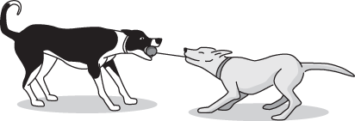1. What must happen before there can be any motion to the left.

Study the diagram of the rope, pulley, and block.

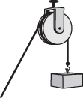The block is not moving. Gravity pushes down on the block with a force of 10 newtons. The friction that resists the turning of the pulley acts with a force of 2 newtons.

2. What force acting on the rope must be exceeded in order for the rope to pull the block higher?

3. Which force would cause this box to move to the left?

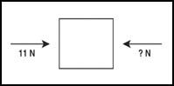

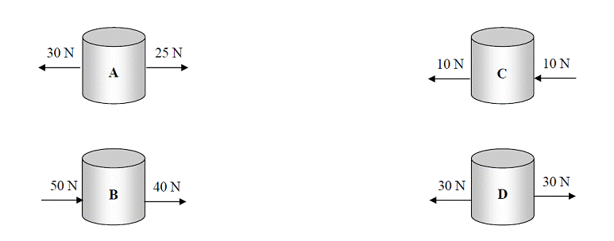4. The forces represented by the arrows in the diagrams are applied to the four objects that are at rest on a table. Predict the direction each object will move when the forces represented in the diagram are applied.

5. The lady is pulling her dog on a leash. The dog exerts a force of 10 Newtons to the left. The lady exerts a force of 25 Newtons to the right. What is the net force on the leash?

6. What happens when an object has unbalanced forces acting on it?

7. What is required to change the direction of a moving object?

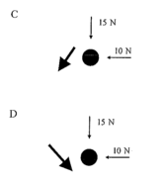8. The diagrams below show below show forces acting on a ball. Draw an arrow which best represents the motion of the ball after the forces have been applied to it.

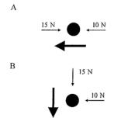

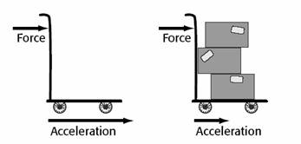

9. Based on the illustration below, it can be inferred that the acceleration of the cart on the left.

10. What happens when two forces act on an object in the same direction?

11. Two groups of children having a tug of war. The children on the left are exerting a force of 550 Newtons (N) to the left. The children on the right are exerting a force of 530 Newtons (N) to the right. How large, and in what direction, is the net force acting on the rope?

12. What is Newton’s First Law of Motion?

13. What is Newton’s Second Law of Motion?

14. What is Newton’s Third Law of Motion?

15. Which law does this represent?

A. A rocket’s escaping gases push up on the ground, and the rocket pushes down on the ground causing the rocket to move down.

B. A roller skater pushes down on the roller skate, and the roller skate pushes down on the wheels causing the roller skater to move down.

C. A swimmer’s hand pushes on the water, and the water pushes back on the swimmers hand

causing the swimmer to move forward.

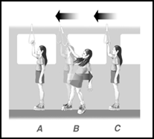D. A skate boarder pushes back on the ground, and the ground pushes down on the skate board causing the skate boarder to move forward.

16. Drawing A shows a girl waiting for a train to start moving. Drawing B shows what happens to the girl when the train starts moving forward. Drawing C shows that after the train is moving at a constant speed and in one direction, the girl has no trouble standing. In which direction will the girl move if the train conductor stops the train suddenly?

17. A rolling soccer ball stops because the unbalanced forces of friction slow it down. Which of the following Laws best demonstrates this phenomenon?

18. Describes acceleration?

19. Which of Newton’s Laws do the following go with?

A. Jump up by pushing down on the trampoline

B. A baseball will break a window but a paper ball will not

C. Pushing back on the ground in order to walk forward

D. The importance of wearing vehicle restraints in the car

20. Why is a passenger who is not wearing a seatbelt likely to hit the windshield in a head-on collision?

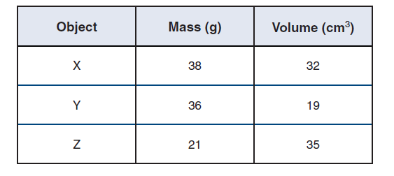21. How does mass affect inertia?

22. If a force of 50 N is applied to each of the three objects, which one will have the most acceleration? Why?

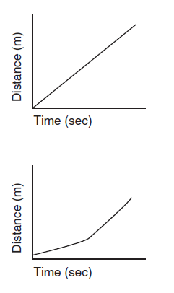23. Describe how a car would travel with each graph.



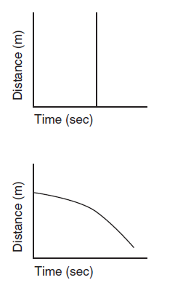

1. A bowling ball and a golf ball are both dropped at the same time from the same height. If there is no friction from air resistance, what is going to happen?



Use the information below to answer questions 25-26.

1. What is the average speed of Animal A during the race?
2. If all animals started the race at the same time, which animal has the greatest seed during the first 10 seconds of the race?

Use the table below to answer question 27.



1. A spring scale is used to pull each of the four objects. Based on the information provided, which object experiences the least amount of acceleration when pulled with 8N of force?

Use the information below to answer question 28.



A student observes and records observations at a track meet.

1. Based on the observations, the runners do not accelerate during…



1. Between which two locations would the greatest change in speed most likely occur?
2. What point has the largest potential energy?
3. 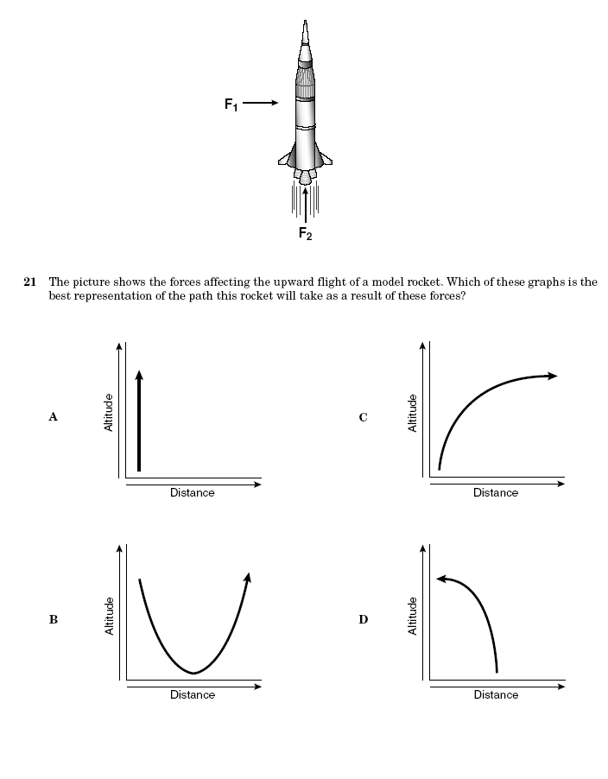What point has the largest kinetic energy?
4. Draw a graph of what the pathways should look like based on this model of a rocket.
5. A car is moving forward on an expressway at a constant speed. If the car’s brakes are applied suddenly, how will passengers in the car tend to move?
6. Describes the relationship among mass, force, and acceleration according to Newton’s second law of motion.
7. According to Newton’s first law, what would happen to a baseball flying through the air if no unbalanced forces acted on it?

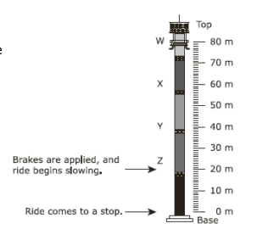

1. The diagram represents an amusement park ride that allows riders to experience free fall. At which point on the ride are the potential energy and the kinetic energy of the riders approximately equal?
2. Where would the most potential energy be?
3. Where would the most kinetic energy be?

1. What is the difference between speed of a moving object and its velocity?
2. A student is investigating unbalanced forces acting on a moving object. What information is needed to know if a force acting on a moving object will cause a change in the motion of the object?
3. A skydiver jumping from a plane experiences the opposing forces of gravity and

42. Describe and Draw the structure of an atom?

43. Scientists use the atomic mass unit to measure the particles in an atom.  An atom that contains six protons, eight neutrons, and six electrons has a mass of approximately…

44. Draw a carbon atom.

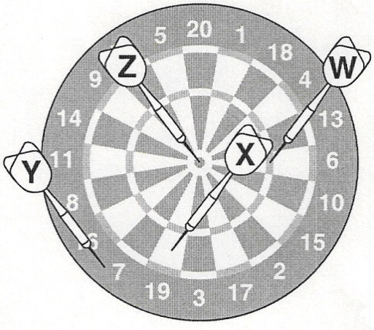45. If the dartboard above is used to model an atom, which dart indicates where the protons and neutrons are located?

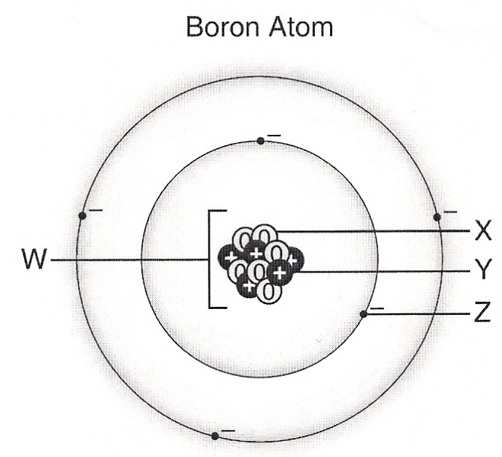

46. What is W pointing to?

47. What is X pointing to?

48. What is Y pointing to?

49. What is Z pointing to?

|  |  |  |  |
| --- | --- | --- | --- |
| Element | Protons | Neutrons | Electrons |
| Hydrogen | 1 | 0 | 1 |
| Beryllium | 4 | 5 | 4 |
| Nitrogen | 7 | 7 | 7 |
| Fluorine | 9 | 10 | ? |

50. Based on the table shown above, how many electrons is a fluorine atom most likely to have?

51. Examine the modern periodic table of the elements.  Elements arranged in the same vertical columns form groups that have…

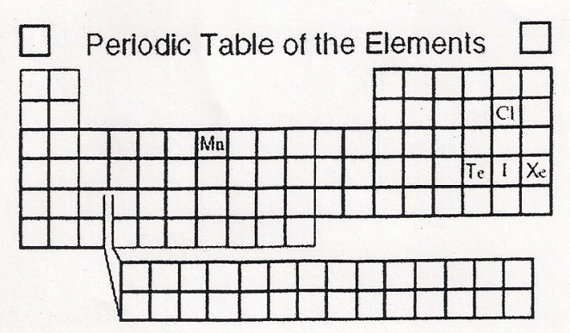52. A recently discovered chemical element can be artificially produced by scientists. This element is called Ununhexium. It has 116 protons in its nucleus and has physical and chemical properties similar to Polonium and Tellurium. Ununhexium is not shown on your periodic table. In what group would this new element be placed?

53. Based on the periodic table on the right, Iodine (I) would have chemical properties most like____________. Why?

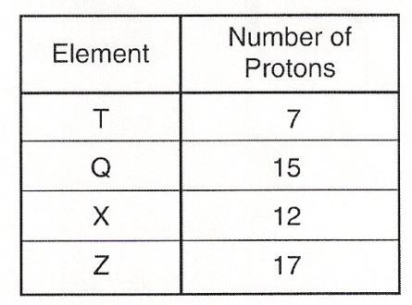54. The table on the right shows the number of protons in an atom of four different elements. According to the periodic table, What group would they be in? Which one(s) are metals? Which one(s) are non-metals?

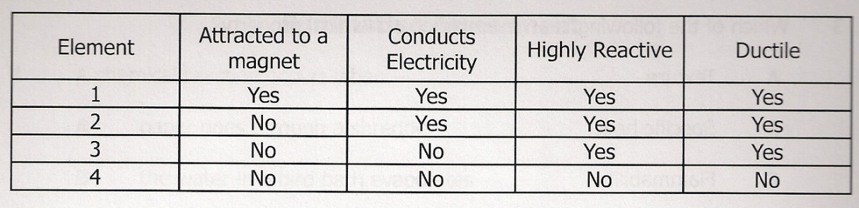55. Which element in the table above is most likely located in group 18 of the Periodic Table? Why?

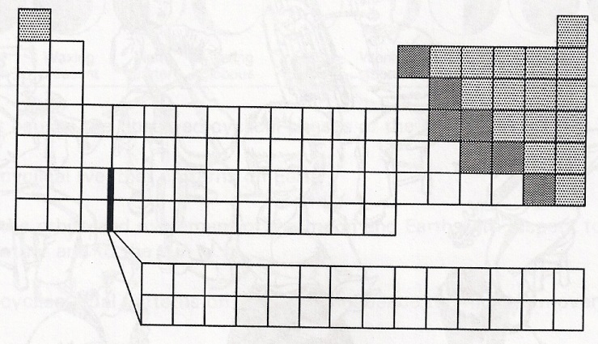56. An element’s physical and chemical properties can be predicted based on its location in the modern periodic table. Based on your knowledge of the arrangements of elements in the modern periodic table, what do all of the elements located in the white, un-shaded boxes have in common?

Use the following partial periodic table of elements to answer Question #57.

|  |  |  |  |  |  |  |  |  |  |
| --- | --- | --- | --- | --- | --- | --- | --- | --- | --- |
|  | **IA**  **1** |  |  |  |  |  |  |  | **VIIIA**  **18** |
| **1** | 1  **H**  Hydrogen  1.008 | **IIA**  **2** |  | **IIIA**  **13** | **IVA**  **14** | **VA**  **15** | **VI**  **16** | **VII**  **17** | 2  **He**  Helium  4.003 |
| **2** | 3  **Li**  Lithium  6.941 | 4  **Be**  Beryllium  9.012 |  | 5  **B**  Boron  10.811 | 6  **C**  Carbon  12.011 | 7  **N**  Nitrogen  14.007 | 8  **O**  Oxygen  15.999 | 9  **F**  Fluorine  18.998 | 10  **Ne**  Neon  20.179 |
| **3** | 11  **Na**  Sodium  22.990 | 12  **Mg**  Magnesium  24.305 |  | 13  **Al**  Aluminum  26.982 | 14  **Si**  Silicon  28.086 | 15  **P**  Phosphorus  30.974 | 16  **S**  Sulfur  32.066 | 17  **Cl**  Chlorine  35.453 | 18  **Ar**  Argon  39.948 |
| **4** | 19  **K**  Potassium  39.098 | 20  **Ca**  Calcium  40.078 |  |  |  |  |  |  |  |

57. Based on the partial periodic table above, which element has physical and chemical properties most similar to Sodium (Na)?

58. Which two subatomic particles are located in the nucleus of an atom?

59. Which subatomic particle has a negative charge?

60. An atom with an atomic number of 26 and an atomic mass of 56 will have how many neutrons?

61. Which subatomic particle has a positive electrical charge?

62. Why do atoms have an overall neutral charge?

**Use the following diagram to answer Questions 63-66.**

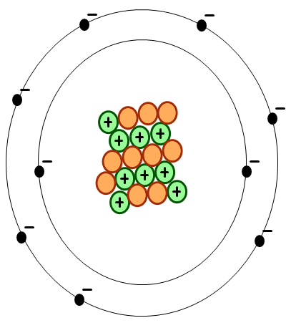

63. What is the atomic number of the atom shown to the left?

64. What is the atomic mass of the atom shown to the left?

65. What is the Name of the atom in this diagram?

66. How many protons, neutrons, and electrons does the atom have?

67. Draw a Bohr model of a Beryllium (Be) atom.

68. How do you find the atomic number of an element on the periodic table? What is the atomic number of Selenium (Se)?

69.How do you find the atomic mass of an element on the periodic table? What is the atomic mass of Selenium (Se)?

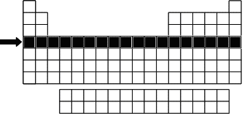

70. The part of the periodic table that is highlighted in the picture to the right is called a…

71. As he was doing research about the periodic table, Jorge discovered that he could accurately predict the number of valence electrons of any element by looking at its position on the periodic table. Using this valuable skill, write down the valence electrons for each Group.

72. Which element on the periodic table has 5 valence electrons in its 3rd energy level?

1. Which group on the Periodic Table most likely contains an element that is highly reactive, a good conductor of electricity, and malleable?
2. What group of elements are the most reactive metals on the Periodic Table?
3. What group of elements are the most reactive nonmetals on the Periodic Table?
4. Kelly was working on her science fair project over the weekend. She wanted to test how different elements would react to water. Out of the choices below, which element would have the most violent reaction?
   1. Sodium
   2. Lithium
   3. Cesium
   4. Chlorine
5. What group on the Periodic Table separates the metals from the non-metals?
6. Why are noble gases non-reactive?

**Label the following parts of a chemical equation.**

84.

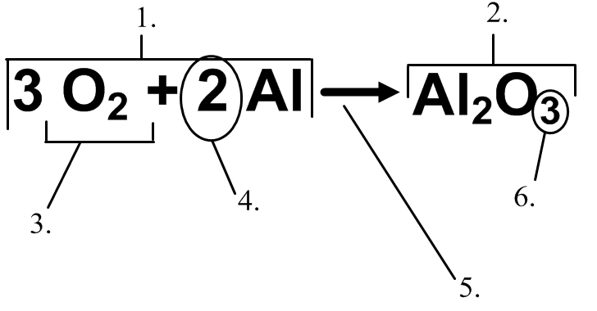

79.

83.

81.

80.

82.

85. Are these chemical or physical changes?

a. Food digesting in the small intestine

b. Water freezing in a pond in winter

c. Dissolving sugar in tea

d. Adding food coloring to water

e. A pot of water boiling

f. An iron nail rusting

g. Corn being ground

h. Sugar dissolving in tea

i. Cutting paper

j. Evaporation

k. Frying an egg

l. Milk souring

86. A drain cleaner consists of sodium hydroxide and aluminum. When the drain cleaner is added to water, bubbles of hydrogen are produced, and the solution becomes very hot. Describe what happens to form the bubbles when the cleaner is added to water?

http://ritter.tea.state.tx.us/student.assessment/resources/online/2006/grade8/science/images/42graphicaa.gif87. One of the reactions involved in obtaining pure copper (Cu) from copper-containing rock is

Describes the reaction.

88. The equation above shows the chemical reaction for burning coal. Explain the reaction represented by this equation.

**C (solid) + O2 (gas) 🡪 CO2 (gas)**

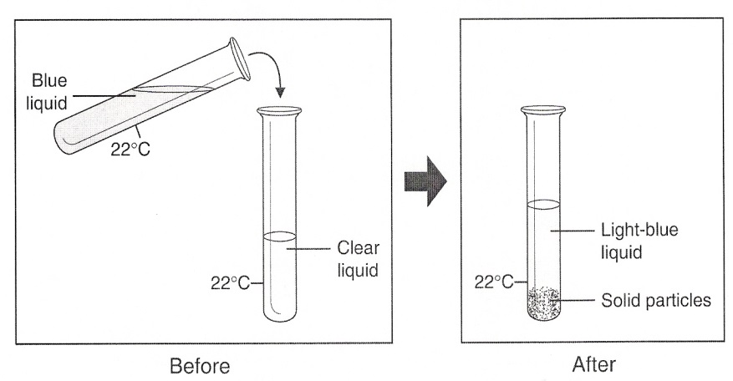89. The pictures above show a blue liquid being added to a clear liquid. Which is the best evidence that a chemical reaction may have occurred?

90. How many elements are in the compound **Mg(OH)2**?

91. How many atoms of each element are in the compound **Mg(OH)2**

92. How many molecules are in **3Mg(OH)2**

93. What are the signs that a chemical reaction occurred?

94. Are these chemical equations balanced or unbalanced?

a. C3H8 + O2 🡪 3CO2 + 4H2O

b. RbBr + AgCl 🡪 AgBr + RbCl

c. WO3 + 3H2 🡪 W + 3H2O

d. Zn + 2HCl 🡪 ZnCl2 + H2

95. How does the Law of Conservation of mass affect this chemical equation?

Zn + 2HCl 🡪 ZnCl2 + H2

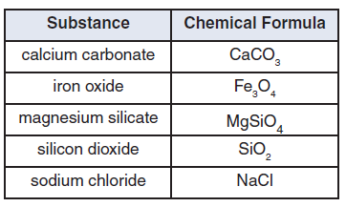Use the data table below to answer questions 96-98.

96. Which of these models best represents one molecule of iron oxide?

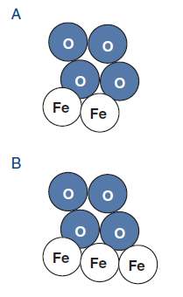

97. The substance in the chart that has the least number of atoms in each molecule is

98. One way calcium carbonate and magnesium silicate are alike is that both

99. Here are four situations in which matter goes through a change. Label if they are a chemical or physical change.

1. Iron glows a bright yellow-orange in a hot furnace.
2. Copper reacts with sulfur to form a bluish-green coating.
3. Silver slowly turns black when it reacts with sulfur in the air.
4. Salt crystals are left on a pan bottom after all the water has boiled out.

100. When aluminum reacts with iron oxide, pure iron and aluminum oxide are produced. To understand the numbers of atoms and molecules involved in this reaction, which type of data display is MOST appropriate?

101. A student places a thin strip of gray metal in a test tube containing a clear liquid. The next day, the metal has disappeared and the liquid is yellow. This is an example of a – ? Why?

102. A piece of wood burned, and ashes remain. How do you know that a chemical reaction took place?

103. What is a solid that forms from a solution during a chemical reaction?

104. In a laboratory, hydrogen gas is combined with one-half as much oxygen gas to produce the liquid commonly called water. What evidence suggests that a chemical reaction has occurred?

105. Are the following a physical or chemical change?

* 1. Blue copper sulfate crystals are dissolved in water and a clear blue solution is formed.
  2. Salt and pepper is shaken on your French fries to improve the flavor.
  3. Phenol red powder is dissolved in water and a red solution is formed.
  4. Two clear solutions are mixed together and a thick yellow substance is formed.

106. How does a balanced chemical equation demonstrate the law of conservation of mass?

107. Find the following for this chemical formula. **3** **H2O**

A. H = C. Total Atoms =

B. O = D. number of molecules =

108. Find the following for this chemical formula. **4 CaCl2**

A. H = C. Total Atoms =

B. O = D. number of molecules =

109. Find the following for this chemical formula. **Fe(OH2)3**

A. H = C. Total Atoms =

B. O = D. number of molecules =

110. This this chemical equation balanced?

**2 C2H6 + 6 O2 🡪 4 CO2 + 6 H2O**