No More Flashdrives!

Creating a Gmail account for cross device storage and retrieval

1. Using Chrome as your browser, go to [www.google.com](http://www.google.com)
2. Set up your FREE Gmail account if you don’t already have one.

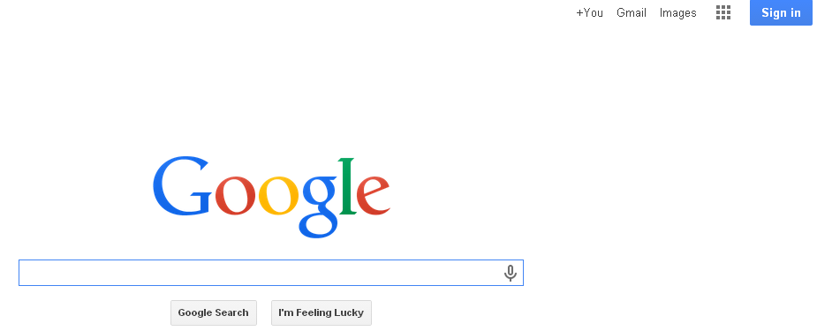

1. Once you have your Gmail account set up, click on the checker board to access of the apps associated with Google—such as Google drive. Google drive is where you will create and store all of your documents, presentations, etc.

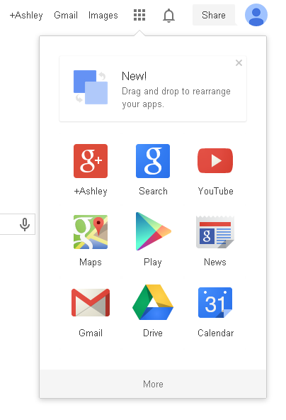

Click here to access apps you can use for school assignments.

1. Once you click on Drive, you are given the option to create:

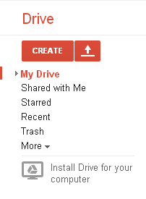

1. Once you click “Create”, you can choose the kind of document you wish to create:

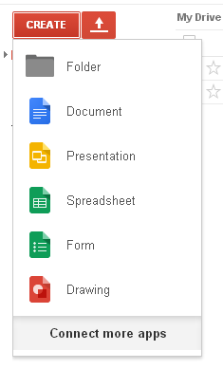

Like **Word.** Use to type papers.

Like **Excel.** Use to create spreadsheets.

Like **PowerPoint.** Use to create presentations.

Another GREAT feature is Google’s **Research tool**. You can research a subject while creating the document. Type in your search terms and once your search loads, mouse over the link and an automatic citation tool loads. Simply click “Cite” and Googledocs automatically inserts the web citation into your document. “Insert Link” embeds the link into your paragraph.



The list of web sources containing info about my search terms: a judge who was caught cheating on a paper. Scandalous!

Click this button and Googledocs will add this source to your document.

My search terms.

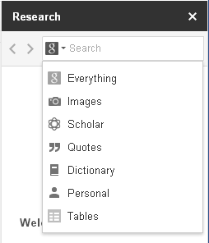

Grab images, look up words, qet quotables and access Google Scholar, too.