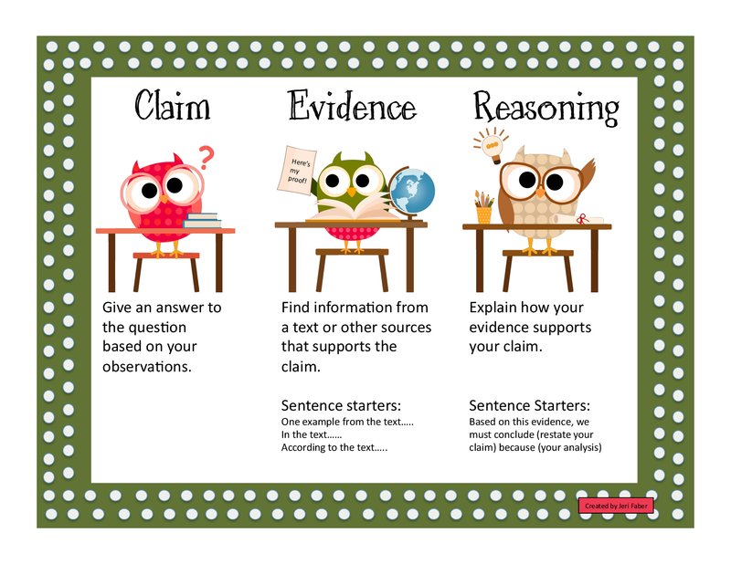

CER: Evidence-Based Response 
CER = Claim + Evidence + Reasoning 
Claim: 
A direct response/answer to a 
question or prompt 
1. Claim 
State a direct response to the 
questionlprompt. 
Helpful Hints: 
Use key words and ideas provided 
in the question or prompt as you 
write your claim. 
Avoid using openings such as "I 
think" or "I believe." 
Evidence: 
Information from a reliable 
source/text/data 
How to Use CER 
2. Evidence 
Provide reliable information 
that supports the claim. 
Helpful Hints: 
Here are suggested sentence 
starters: 
In the text... 
The text statesm 
According to the passagem 
One example from the textm 
The author states... 
One piece of evidence ism 
The data indicates... 
Based on my observationsm 
Reasoning: 
Your explanation of how 
evidence supports claim 
3. Reasoning 
Explain how the evidence 
supports the claim. 
Helpful Hints: 
This portion must offer new 
insight, analysis, 
acknowledgement of 
connections between ideas, etc. 
Here is a suggested sentence 
starter: Based on this evidence, 
we must conclude (rephrase 
your claim) because (your 
analysis). 
More Sentence Starters for Your Reasoning 
A logical conclusion we can draw from this evidence 
is that (rephrase your claim) because (your analysis). 
This is important because (explain why in a way that 
directly relates to the claim). 
The fact that (rephrase your evidence) shows that 
(rephrase your claim) because (your analysis). 
This proves that (rephrase your claim) because 
(your analysis). 
Based on this evidence, we conclude (rephrase claim) 
(analysis). 
These facts work together to build a case that (rephrase 
claim) because (your analysis). 
(Rephrase your evidence) matters because (give your 
reasoning). Thus, (rephrase your claim) because 
(your analysis). 
This (illustration, graph, statisticletc.) is strong 
evidence that (rephrase claim) because (your analysis). 
Considered together, the fact that (rephrase one piece 
of evidence), and that (rephrase more evidence), 
clearly demonstrate that (rephrase claim) because because (your analysis). 