Algebra II Name __________________________________

Cubic/Cube Root Review Period________ Date_______________

*Graph each equation*

1. 2. 3.

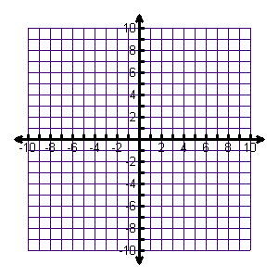

*List* ***ALL*** *transformations*

4. 5. 6.

*Write the inverse of each function*

6. 7. 8.

*Graph the inverse of each function*

9. 10. 11.



*Prove by composition*

12. 13. 14.

*Solve for x and check your solution*

15. 16. 17.

18. 19. 20.