**Section 1: Thermo**

1. A certain gas is compressed adiabatically. The amount of work done on the gas is 800 J. What is the change in the internal (thermal) energy of the gas?

A) 800 J

B) -800 J

C) 400 J

D) 0 J

E) More information is needed to answer this question.

1. A cyclic process is carried out on an ideal gas such that it returns to its initial state at the end of a cycle, as shown in the *pV* diagram in the figure. If the process is carried out in a clockwise sense around the enclosed area, as shown on the figure, then the change of internal energy over the full cycle

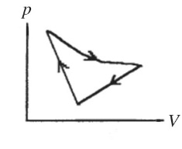

A) is positive.

B) is negative.

C) is zero.

D) cannot be determined from the information given.

1. The second law of thermodynamics leads us to conclude that

A) the total energy of the universe is constant.

B) disorder in the universe is increasing with the passage of time.

C) it is theoretically possible to convert heat into work with 100% efficiency.

D) the average temperature of the universe is increasing with the passage of time.

1. If the efficiency of a Carnot engine were to be 100%, the heat sink would have to be

A) at absolute zero.

B) at 0°C.

C) at 100°C.

D) infinitely hot.

1. An ideal gas undergoes an isothermal expansion. During this process, its entropy

A) decreases.

B) remains unchanged.

C) increases.

D) cannot be predicted from the data given.

1. A thermally isolated system is made up of a hot piece of aluminum and a cold piece of copper, with the aluminum and the copper in thermal contact. The specific heat capacity of aluminum is more than double that of copper. Which object experiences the greater magnitude gain or loss of heat during the time the system takes to reach thermal equilibrium?

A) the aluminum

B) the copper

C) Neither one; both of them experience the same size gain or loss of heat.

D) It is impossible to tell without knowing the masses.

E) It is impossible to tell without knowing the volumes.

1. Two containers of equal volume each hold samples of the same ideal gas. Container A has twice as many molecules as container B. If the gas pressure is the same in the two containers, the correct statement regarding the absolute temperatures *T*A and *T*B in containers A and B, respectively, is

A) *T*A = *T*B.

B) *T*A = 2*T*B.

C) *T*A = *T*B.

D) *T*A = *T*B.

E) *T*A = *T*B.

1. A gas is taken through the cycle shown in the *pV* diagram in the figure. During one cycle, how much work is done by the gas?

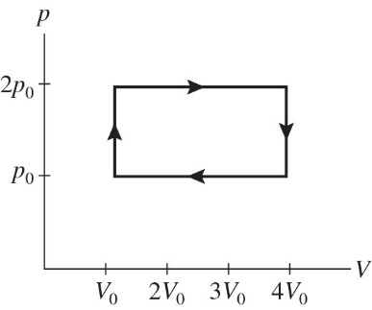

A) *p*0*V*0

B) 2 *p*0*V*0

C) 3 *p*0*V*0

D) 4 *p*0*V*0

1. A balloon originally has a volume of 1.0 m3 when the gas in it is at 20°C and under a pressure of 1.0 atm. As it rises in the earth's atmosphere, its volume expands. What will be its new volume if its final temperature and pressure are -40°C and 0.10 atm?

A) 2.0 m3

B) 4.0 m3

C) 6.0 m3

D) 8.0 m3

1. The figure shows a *pV* diagram for 0.0061 mol of ideal gas that undergoes the process 1 → 2 → 3. What is the pressure *p*2? (*R* = 8.31 J/mol ∙ K)

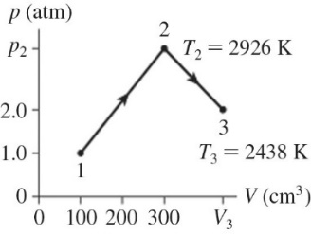

A) 4.9 atm

B) 4.9 × 105 atm

C) 15 atm

D) 1.5 × 106 atm

1. Your lungs hold 4.2 L of air at a temperature of 27°C and a pressure of 101.3 kPa. How many moles of air do your lungs hold? (*R* = 8.31 J/mol ∙ K)
2. The figure shows a *pV* diagram for 2.6 g of ideal helium gas that undergoes the process 1 → 2 → 3. Find the value of volume *V*3*.* The atomic mass of helium is 4.0 g/mol, and *R* = 8.31 J/mol ∙ K.

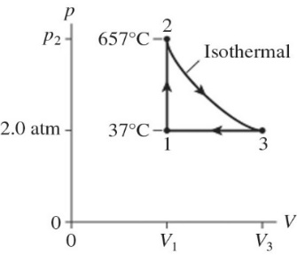

1. The figure shows a *pV* diagram for 8.3 g of ideal nitrogen gas N2 in a sealed container. The temperature of state 1 is 59°C, the atomic mass of the nitrogen atom is 14 g/mol, and *R* = 8.31 J/mol ∙ K. What are (a) pressure *p*1 and (b) temperature *T*2?

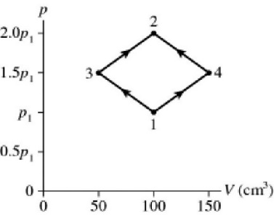

1. For a certain ideal Carnot engine, the hot reservoir is 35 C° higher than the cold reservoir. If this engine is to have an efficiency of 20%, what must be the temperature of the hot reservoir?
2. The figure shows a *pV* diagram for 0.98 mol of ideal gas that undergoes the process 1 → 2. The gas then undergoes an isochoric heating from point 2 until the pressure is restored to the value it had at point 1. What is the final temperature of the gas? (*R* = 8.31 J/mol ∙ K).

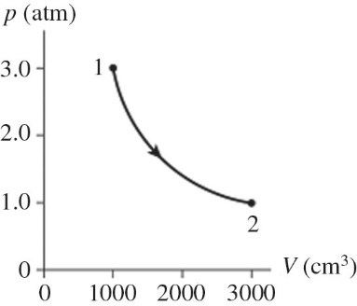

1. The figure shows a *pV* diagram for an ideal gas that is carried around a cyclic process. How much work is done in one cycle if *p*0 =  and  L? (1.00 atm = 101 kPa)

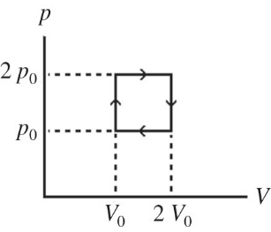

1. An ideal gas undergoes the process *a→b→c→a* shown in the *pV* diagram. In this figure, *Pa* = *Pc* = 3.60 × 105 Pa, *Vb* = *Vc* = 68.00 L, *Va* = 35 L, and *Pb* = 5.60 × 105 Pa. How much work is done by the system in this process?

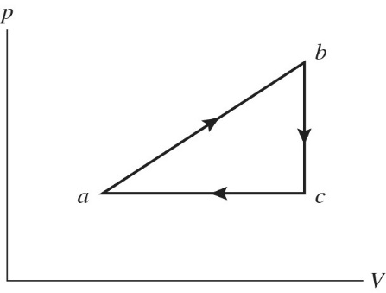

1. What is absolute zero on the (a) Celsius scale and (b) on the Fahrenheit scale?
2. A monatomic ideal gas undergoes an isothermal expansion at 300 K, as the volume increased from  to  The final pressure is  What is the change in the internal (thermal) energy of the gas during this process? (*R* = 8.31 J/mol ∙ K)
3. The figure shows a *pV* diagram for a gas going through a cycle from A to B to C and back to A. From point A to point B, the gas absorbs 50 J of heat and finds its internal (thermal) energy has increased by 20 J. Going from B to C, the internal (thermal) energy decreases by 5.0 J.

(a) How much work was done by the gas from A to B?

(b) How much heat was absorbed by the gas from B to C?

(c) How much work was done by the gas going from B to C?

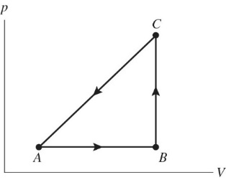

**Section 2: Fluids**

1. A styrofoam sphere of radius *R* has a density *ρ*. You now carefully compress the sphere so its radius is *R*/2. What is the density of the compressed sphere?

A) 2 *ρ*

B) 4 *ρ*

C) *ρ*

D) *ρ*

E) 8 *ρ*

1. As shown in the figure, fluid fills a container having several sections. At which of the indicated points is the pressure greatest?

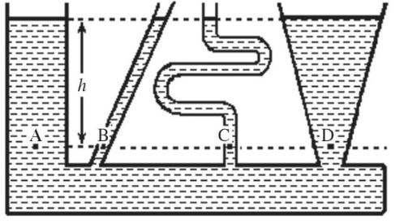

A) A

B) B

C) C

D) D

E) The pressure is the same at each of the labeled points.

1. Consider a brick that is totally immersed in water, with the long edge of the brick vertical. The pressure on the brick is

A) the same on all surfaces of the brick.

B) greatest on the face with largest area.

C) greatest on the top of the brick.

D) greatest on the sides of the brick.

E) greatest on the bottom of the brick.

1. A cubical block of stone is lowered at a steady rate into the ocean by a crane, always keeping the top and bottom faces horizontal. Which one of the following graphs best describes the gauge pressure *p* on the bottom of this block as a function of time *t* if the block just enters the water at time *t* = 0 s?

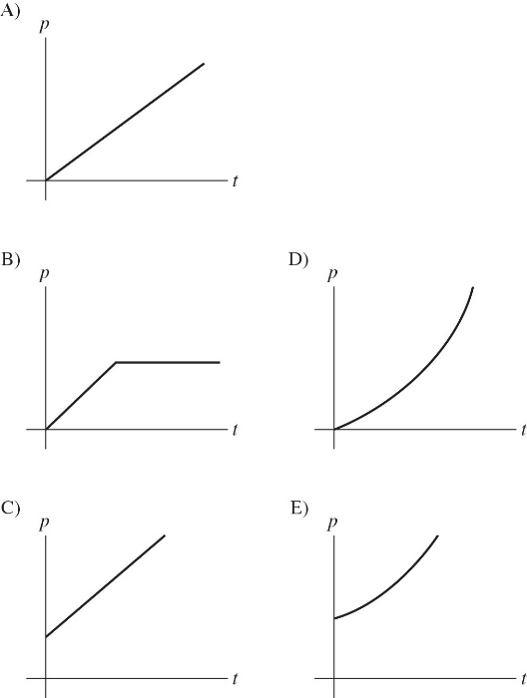

1. A cubical block of stone is lowered at a steady rate into the ocean by a crane, always keeping the top and bottom faces horizontal. Which one of the following graphs best describes the absolute (total) pressure *p* on the bottom of this block as a function of time *t* if the block just enters the water at time *t* = 0 s?

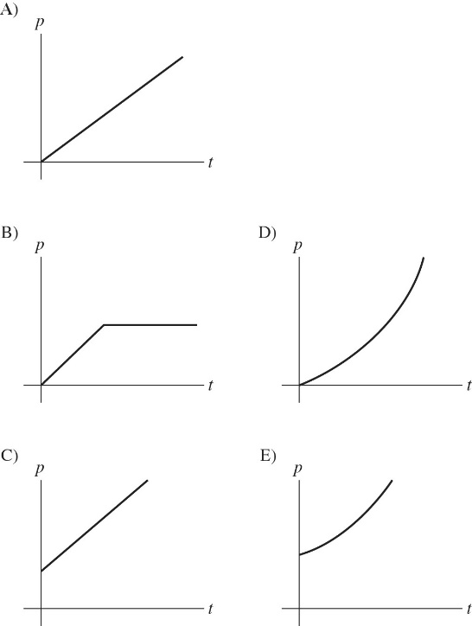

1. A cubical block of stone is lowered at a steady rate into the ocean by a crane, always keeping the top and bottom faces horizontal. Which one of the following graphs best describes the buoyant force *B* on this block as a function of time *t* if the block just enters the water at time *t* = 0 s?

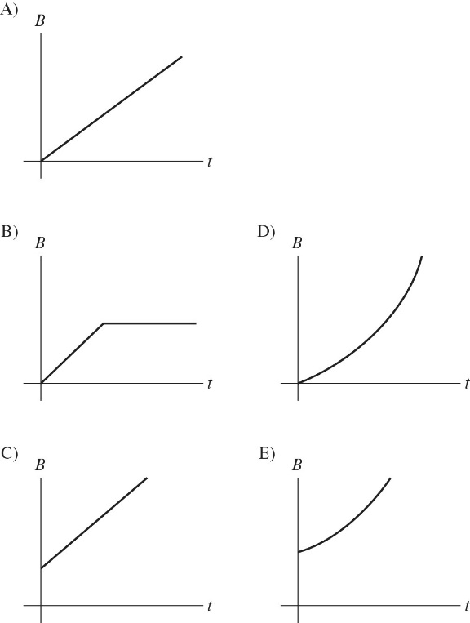

1. A spherical ball of lead (density 11.3 g/cm3) is placed in a tub of mercury (density 13.6 g/cm3). Which answer best describes the result?

A) The lead ball will float with about 83% of its volume above the surface of the mercury.

B) The lead ball will float with its top exactly even with the surface of the mercury.

C) The lead ball will float with about 17% of its volume above the surface of the mercury.

D) The lead will sink to the bottom of the mercury.

1. Salt water has greater density than fresh water. A boat floats in both fresh water and in salt water. Where is the buoyant force greater on the boat?

A) in salt water

B) in fresh water

C) The buoyant force is the same in both cases.

1. Salt water is denser than fresh water. A ship floats in both fresh water and salt water. Compared to the fresh water, the volume of water displaced in the salt water is

A) more.

B) less.

C) the same.

D) Cannot be determined because we do not know the volume of the ship.

1. A 10-kg piece of aluminum sits at the bottom of a lake, right next to a 10-kg piece of lead, which is much denser than aluminum. Which one has the greater buoyant force on it?

A) the aluminum

B) the lead

C) Both have the same buoyant force.

D) It cannot be determined without knowing their volumes.

1. As shown in the figure, a large open tank contains a layer of oil ( density 450 kg/) floating on top of a layer of water (density 1000 kg/m3) that is 3.0 m thick, as shown in the sketch. What must be the thickness of the oil layer if the gauge pressure at the bottom of the tank is to be 

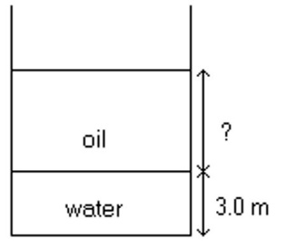

1. A container consists of two vertical cylindrical columns of different diameter connected by a narrow horizontal section, as shown in the figure. The open faces of the two columns are closed by very light plates that can move up and down without friction. The tube diameter at *A* is 35.0 cm and at *B* it is 10.2 cm. This container is filled with oil of density 0.820 g/cm3. If a 125-kg object is placed on the larger plate at *A*, how much mass should be placed on the smaller plate at *B* to balance it?

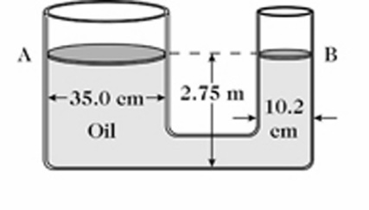

1. The small piston of a hydraulic lift has a diameter of 8.0 cm, and its large piston has a diameter of 40 cm. The lift raises a load of 15,000 N. Assume the pistons each have negligible weight.

(a) Determine the force that must be applied to the small piston.

(b) Determine the pressure applied to the fluid in the lift.

1. A piece of aluminum with a mass of 1.0 kg and density of 2700 kg/m3 is suspended from a light cord and then completely immersed in a container of water having density 1000 kg/m3.

(a) Determine the volume of the piece of aluminum.

(b) Determine the tension in the cord when the aluminum is immersed in the container of water.

1. A wooden raft has a mass of 55 kg. When empty it floats in water (density  with 64% of its volume submerged. What maximum mass of sand can be put on the raft without sinking it?
2. An ideal incompressible fluid flows at 0.252 m/s through a 44-mm diameter cylindrical pipe. The pipe widens to a *square* cross sectional area that is 5.5 cm on a side. Assume steady flow throughout the system.

(a) What is the speed of the fluid through the square section of pipe?

1. Water flows out of a large reservoir through an open pipe, as shown in the figure. What is the speed of the water as it comes out of the pipe?

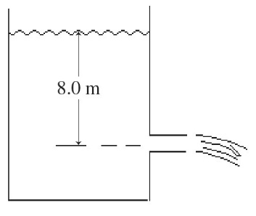

1. A large cylindrical water tank 11.5 m in diameter and 13.5 m tall is supported with its base 8.75 m above the ground by a stand as shown in the figure. The water level in the tank is 10.6 m deep, and the density of the water in the tank is 1.00 g/cm3. A very small hole is formed at the base of the vertical wall of the tank, and water is squirting out of this hole horizontally. When this water hits the ground, how far has it traveled horizontally from the hole, assuming no air resistance?

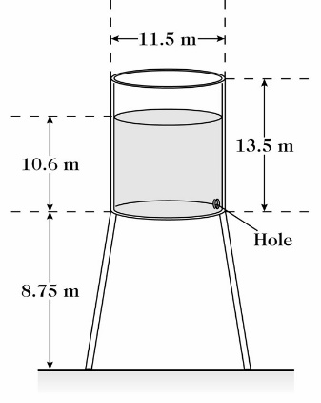

**Section 3: Electrostatics**

1. A plastic rod is charged up by rubbing a wool cloth, and brought to an initially neutral metallic sphere that is insulated from ground. It is allowed to touch the sphere for a few seconds, and then is separated from the sphere by a small distance. After the rod is separated, the rod

A) is repelled by the sphere.

B) is attracted to the sphere.

C) feels no force due to the sphere.

1. A negatively-charged plastic rod is brought close to (but does not touch) a neutral metal sphere that is connected to ground. After waiting a few seconds, the ground connection is removed (without touching the sphere), and after that the rod is also removed. The sphere is now

A) negatively charged.

B) positively charged.

C) neutral.

1. 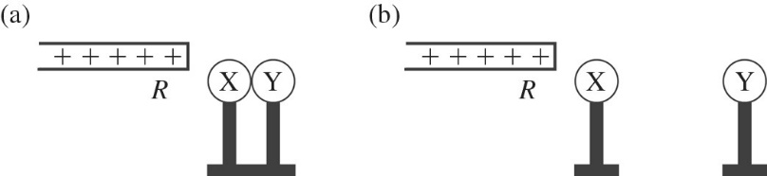

X and Y are two initially uncharged metal spheres on insulating stands, and they are in contact with each other. A positively charged rod *R* is brought close to X as shown in part (a) of the figure. Sphere Y is now moved away from X, as shown in part (b). What are the final charge states of X and Y?

A) Both X and Y are neutral.

B) X is positive and Y is neutral.

C) X is neutral and Y is positive.

D) X is negative and Y is positive.

E) Both X and Y are negative.

1. Two point charges, *Q*1 and *Q*2, are separated by a distance *R*. If the magnitudes of both charges are doubled and their separation is also doubled, what happens to the electrical force that each charge exerts on the other one?

A) It increases by a factor of 2.

B) It increases by a factor of ** .

C) It is reduced by a factor of **.

D) It increases by a factor of 4.

E) It remains the same.

1. Four point charges of equal magnitudes but with varying signs are arranged on three of the corners and at the center of the square of side *d* as shown in the figure. Which one of the arrows shown represents the net force acting on the center charge?

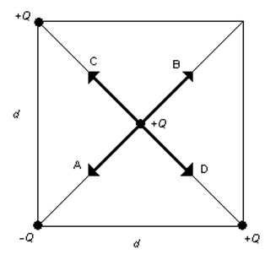

A) A

B) B

C) C

D) D

1. Four point charges *Q* of equal magnitude and sign are arranged on three of the corners of the square of side *d* as shown in the figure Which one of the arrows shown represents the net force acting on the charge at the upper right hand corner of the square?

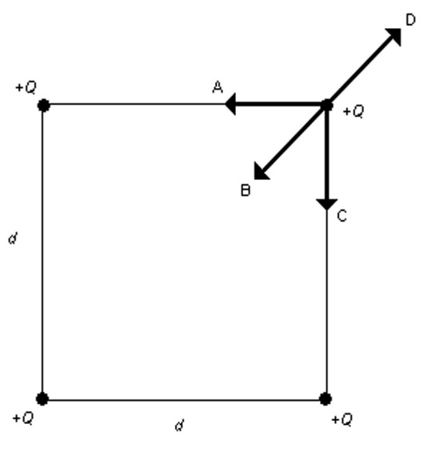

A) A

B) B

C) C

D) D

1. Four point charges of varying magnitude and sign are arranged on the corners of the square of side *d* as shown in the figure. Which one of the arrows shown represents the net force acting on the point charge with a charge +*Q*?

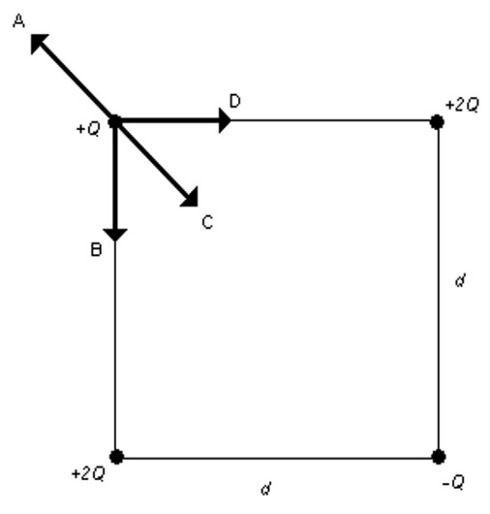

A) A

B) B

C) C

D) D

1. The figure shows electric field lines arising from two small charged particles P and Q. Consider the following two statements:

(i) The charge on P is smaller than the charge on Q.

(ii) The electrostatic force on P is smaller than the force on Q.

Which of the above statements are true?

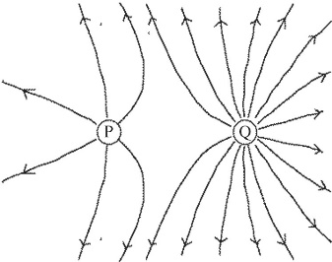

A) Only (i) is true.

B) Only (ii) is true.

C) Both (i) and (ii) are true.

D) Neither (i) nor (ii) is true.

1. Two stationary point charges *q*1 and *q*2 are shown in the figure along with a sketch of some field lines representing the electric field produced by them. What can you deduce from the sketch?

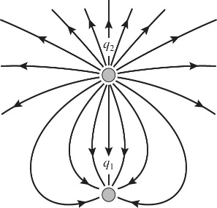

A) *q*1 is negative and *q*2 is positive; the magnitudes are equal.

B) *q*1 and *q*2 have the same sign; the magnitudes are equal.

C) *q*1 is positive and *q*2 is negative; the magnitude of *q*1 is greater than the magnitude of *q*2.

D) *q*1 is negative and *q*2 is positive; the magnitude of *q*1 is less than the magnitude of *q*2.

E) *q*1 and *q*2 have the same sign; the magnitude of *q*1 is greater than the magnitude of *q*2.

1. Which one of the arrows shown in the figure best represents the direction of the electric field between the two uniformly charged metal plates?

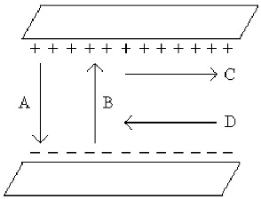

A) A

B) B

C) C

D) D

E) None of the above

1. How many electrons are necessary to produce 1.0 C of negative charge? (*e* = 1.60 × 10-19 C)

A) 6.3 × 1018

B) 6.3 × 109

C) 1.6 × 1019

D) 1.6 × 109

E) 6.0 × 1023

1. Consider a container of 2.0 g of hydrogen, H2 (one mole). Suppose you removed all the electrons and moved them to the other side of the earth (Earth's radius is 6380 km, *k* = 1/4πε0 = 9.0 × 109 N ∙ m2/C2, NA = 6.022 × 1023 molecules/mol, *e* = 1.60 × 10-19 C)

(a) How much charge is left behind after you remove the electrons?

(b) What electric force do the protons exert on the electrons after they are separated as described?

1. How far apart should two protons be if the electrical force of repulsion on each one is equal to its weight on the earth? (*k* = 1/4πε0 = 9.0 × 109 N ∙ m2/C2, *e* = 1.6 × 10-19 C, *m*proton = 1.67 × 10-27 kg)
2. A point charge *Q*1 = +6.0 nC is at the point (0.30 m, 0.00 m); a charge *Q*2 = -1.0 nC is at (0.00 m, 0.10 m), and a charge *Q*3 = +5.0 nC is at (0.00 m, 0.00 m). What are the magnitude and direction of the net force on the +5.0-nC charge due to the other two charges? (*k* = 1/4πε0 = 9.0 × 109 N ∙ m2/C2)
3. Three point charges are placed on the *x*-axis, as follows. A charge of +2.0 μC is at the origin, a charge of -2.0 μC is at *x* = 50 cm, and a charge of +4.0 μC is at *x* = 100 cm. What are the magnitude and direction of the electrostatic force on the charge at the origin due to the other two charges? (*k* = 1/4πε0 = 9.0 × 109 N ∙ m2/C2)
4. A point charge *Q* = -12 μC, and two other charges *q*2 and *q*2, are placed on *x*-*y* axes as shown in the figure. The electric force components on charge *Q* are *Fx* = +0.005 N and Fy = -0.003 N. (*k* = 1/4πε0 = 9.0 × 109 N ∙ m2/C2, *e* = 1.6 × 10-19 C)

(a) How many excess electrons are there in charge *Q*?

(b) What are the charges q1 and q2, including their signs?

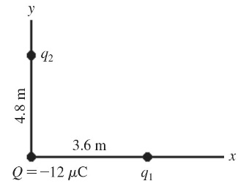

**Section 4: Electric potential**

1. As a proton moves in the direction the electric field lines

A) it is moving from low potential to high potential and gaining electric potential energy.

B) it is moving from low potential to high potential and losing electric potential energy.

C) it is moving from high potential to low potential and gaining electric potential energy.

D) it is moving from high potential to low potential and losing electric potential energy.

E) both its electric potential and electric potential energy remain constant.

1. As an electron moves in the direction the electric field lines

A) it is moving from low potential to high potential and gaining electric potential energy.

B) it is moving from low potential to high potential and losing electric potential energy.

C) it is moving from high potential to low potential and gaining electric potential energy.

D) it is moving from high potential to low potential and losing electric potential energy.

E) both its electric potential and electric potential energy remain constant.

1. As a proton moves in a direction perpendicular to the electric field lines

A) it is moving from low potential to high potential and gaining electric potential energy.

B) it is moving from low potential to high potential and losing electric potential energy.

C) it is moving from high potential to low potential and gaining electric potential energy.

D) it is moving from high potential to low potential and losing electric potential energy.

E) both its electric potential and electric potential energy remain constant.

1. A region of space contains a uniform electric field, directed toward the right, as shown in the figure. Which statement about this situation is correct?

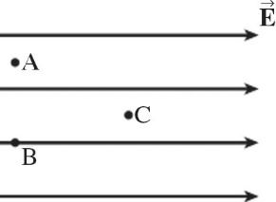

A) The potential at all three locations is the same.

B) The potentials at points A and B are equal, and the potential at point C is higher than the potential at point A.

C) The potential at points A and B are equal, and the potential at point C is lower than the potential at point A.

D) The potential at point A is the highest, the potential at point B is the second highest, and the potential at point C is the lowest.

1. Two ideal parallel-plate capacitors are identical in every respect except that one has twice the plate area of the other. If the smaller capacitor has capacitance *C*, the larger one has capacitance

A) *C*/2.

B) *C*.

C) 2*C*.

D) 4*C*.

1. A battery charges a parallel-plate capacitor fully and then is removed. The plates are then slowly pulled apart. What happens to the potential difference between the plates as they are being separated?

A) It increases.

B) It decreases.

C) It remains constant.

D) It cannot be determined from the information given.

1. Which of the following will increase the capacitance of a parallel-plate capacitor? (There could be more than one correct choice.)

A) a decrease in the plate area and an increase in the plate separation

B) a decrease in the potential difference between the plates

C) an increase in the potential difference between the plates

D) an increase in the plate area and a decrease in the plate separation

E) an increase in the charge on the plates

1. A dielectric material such as paper is inserted between the plates of a capacitor as the capacitor holds a fixed charge on its plates. What happens to the electric field between the plates as the dielectric is inserted?

A) There is no change in the field.

B) The field becomes stronger.

C) The field becomes weaker.

D) The field reduces to zero.

1. How much work must we do on an electron to move it from point A, which is at a potential of +50V, to point B, which is at a potential of -50 V, along the semicircular path shown in the figure? Assume the system is isolated from outside forces. (*e* = 1.60 × 10-19 C)

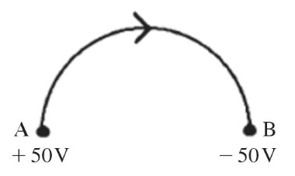

A) 1.6 J

B) 1.60 × 10-17 J

C) -1.60 × 10-17 J

D) -1.6 J

E) This cannot be determined because we do not know the distance traveled.

1. If an electron is accelerated from rest through a potential difference of 1500 V, what speed does it reach? (*e* = 1.60 × 10-19 C , *m*electron = 9.11 × 10-31 kg)

A) 2.3 × 107 m/s

B) 1.9 × 107 m/s

C) 1.5 × 107 m/s

D) 1.1 × 107 m/s

1. Three point charges are placed at the following points in a horizontal *x-y* plane:  is at   is at  and  is at  Calculate the electrical potential (relative to infinity) at the origin due to these three point charges. (*k* = 1/4*πε*0 = 9.0 × 109 N ∙ m2/C2)
2. A very small 4.8-g particle carrying a charge of +9.9 μC is fired with an initial speed of  directly toward a second small 7.8-g particle carrying a charge of + The second particle is held fixed throughout this process. If these particles are initially very far apart, what is the closest they get to each other? (*k* = 1/4*πε*0 = 9.0 × 109 N ∙ m2/C2)
3. Two tiny particles having charges *q*1 = +56.0 nC and *q*2 = -46.0 nC are separated by  and held in place, as shown in the figure. A third particle, having a charge of  is placed at the point A, which is 0.18 m to the left of *q*2. How much work is needed to move the third particle from point A to point B, which is 0.40 m to the left of *q*1. All the points in the figure lie on the same line. (*k* = 1/4*πε*0 = 9.0 × 109 N ∙ m2/C2)

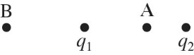

1. The potential difference between two square parallel plates is 4.00 V. If the plate separation is 6.00 cm and they each measure 1.5 m by 1.5 m, what is the magnitude of the electric field between the plates?
2. The equipotential surfaces for two point charges are shown in the figure,with the value of potential marked on the line for each surface.

(a) What is the potential difference, *V*G - *V*D, between points G and D?

(b) What is the potential difference, *V*A - *V*G, between points A and G?

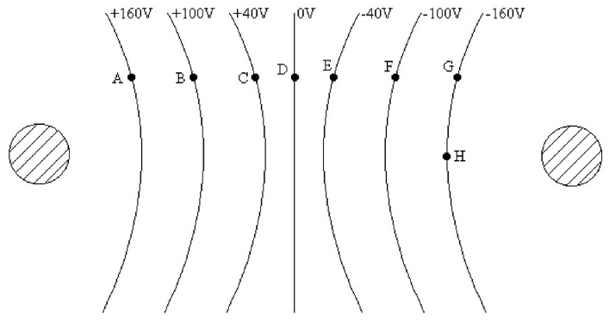

1. An ideal air-filled parallel-plate capacitor consists of plates that are 1.0 mm apart and have an area of 1.5 × 10-4 m2. The capacitor is connected to a 12-V potential source (battery). (ε0 = 8.85 × 10-12 C2/N ∙ m2)

(a) What is the capacitance of this capacitor?

(b) How much charge is on each of its plates?

(c) What is the strength of the electric field between the plates?

1. A 12.0-V battery (potential source) is connected across a 6.00-µF air-filled capacitor.

(a) How much energy can be stored this way?

(b) How much excess charge is on each plate of the capacitor?

Answer: (a) 432 µJ (b) 72.0 µC

**Section 5: Circuits**

1. For the graph shown in the figure, what physical quantity does the slope of the graph represent for ohmic material?

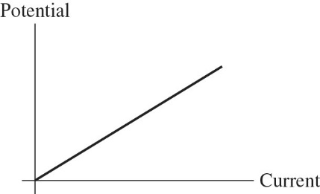

A) power

B) resistivity

C) 1/(resistivity)

D) resistance

E) 1/(resistance)

1. For the graph shown in the figure, what physical quantity does the slope of the graph represent for ohmic material?

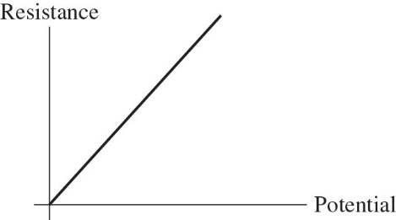

A) current

B) resistivity

C) 1/(current)

D) power

E) 1/(resistivity)

1. What is the voltage drop across a 5.0-Ω resistor if the current through it is 5.0 A?

A) 100 V

B) 25 V

C) 4.0 V

D) 1.0 V

1. A 5-µF, a 7-µF, and an unknown capacitor *C*X are connected in parallel between points *a* and *b* as shown in the figure. What do you know about the equivalent capacitance *Cab* between *a* and *b*? (There could be more than one correct choice.)

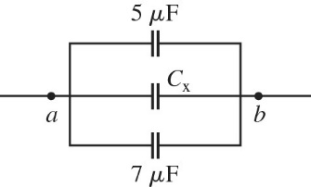

A) *Cab* > 12 µF

B) *Cab* > *C*X

C) 5 µF < *Cab* < 12 µF

D) *Cab* < 5 µF

E) *Cab* < *C*X

1. Suppose you have two capacitors and want to use them to store the *maximum* amount of energy by connecting them across a voltage source. You should connect them

A) in series across the source.

B) in parallel across the source.

C) It doesn't matter because the stored energy is the same either way.

1. 10) Draw a circuit with two batteries, a resistor between them, and a capacitor in parallel with the resistor. The batteries are connected negative pole to positive pole.

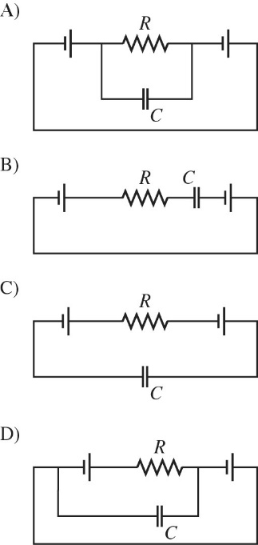

1. When unequal resistors are connected in parallel in a circuit,

A) the same current always runs through each resistor.

B) the potential drop is always the same across each resistor.

C) the largest resistance has the largest current through it.

D) the power generated in each resistor is the same.

1. Kirchhoff's junction rule is a statement of

A) the law of conservation of momentum.

B) the law of conservation of charge.

C) the law of conservation of energy.

D) the law of conservation of angular momentum.

E) Newton's second law.

1. Kirchhoff's loop rule is a statement of

A) the law of conservation of momentum.

B) the law of conservation of charge.

C) the law of conservation of energy.

D) the law of conservation of angular momentum.

E) Newton's second law.

1. If a charge of 11.4 C passes through a computer in 1.75 min, what is the average current through the computer?
2. For the circuit shown in the figure, write the Kirchhoff current equation for the node labeled A. Notice the directions of the currents!

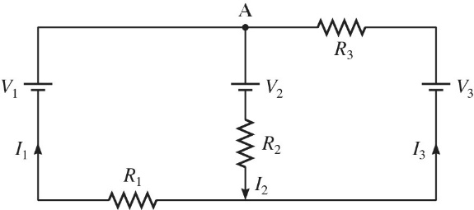

1. For the circuit shown in the figure, write the Kirchhoff loop equation for the entire *outside* loop. Notice the directions of the currents!

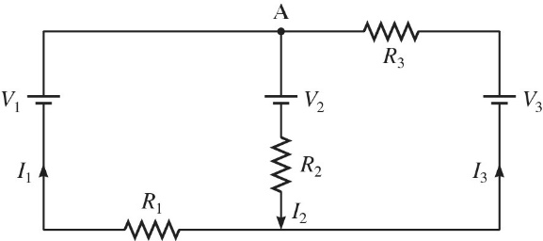

1. A network of capacitors is connected across a potential difference *V*0 as shown in the figure.

(a) What should *V*0 be so that the 60.0-µF capacitor will have 18.0 µC of charge on each of its plates?

(b) Under the conditions of part (a), how much total energy is stored in this network of capacitors?

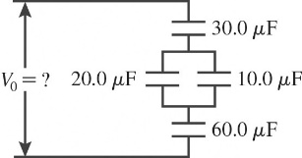

1. A system of four capacitors is connected across a 90-V voltage source as shown in the figure.

(a) What is the potential difference across the plates of the 6.0-µF capacitor?

(b) What is the charge on the 3.0-µF capacitor?

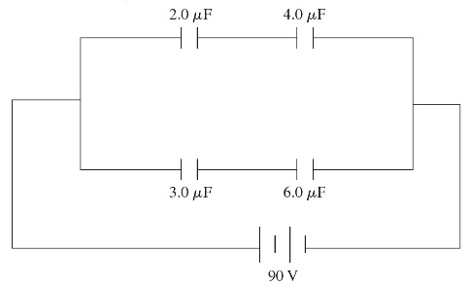

1. What is the equivalent resistance between points A and B of the network shown in the figure?

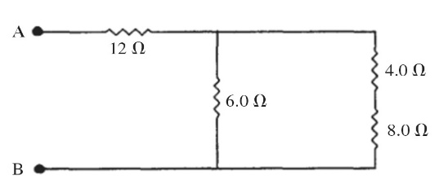

1. What is the equivalent resistance in the circuit shown in the figure?

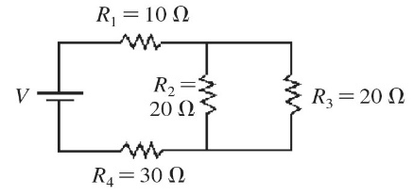

1. What is the equivalent resistance of the circuit shown in the figure? The battery is ideal and all resistances are accurate to 3 significant figures.

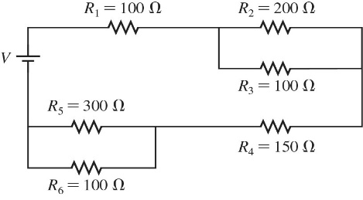

1. A multiloop circuit is shown in the figure. Find the emf *ε*1 if the batteries are ideal. (It is not necessary to solve the entire circuit.)

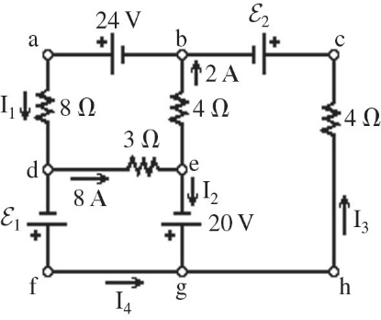

Answer: -4 V