Equations that are not on the AP Physics 1 Formula Sheet

**Keep in mind the equations listed below do not necessarily need to be “memorized.” It is more important to understand the proportionalities rather than the equation itself. For example, for , if you increase mass of the planet, , by a factor of then you increase the orbital velocity by a factor of**

**Banked Curve**

Angle of a banked curve:

This came from Ideal Speed on a Banked Curve:

Maximum speed through a flat turn:

**Circular Motion/Gravitation**

Velocity of a particle moving in a circle:

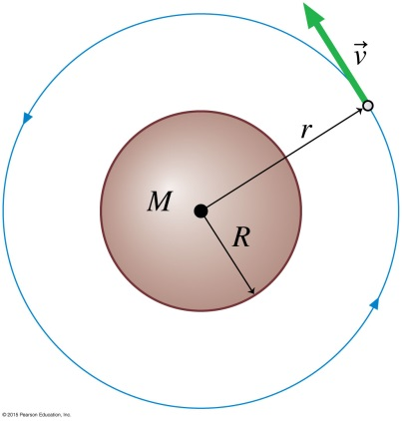Gravitational field/acceleration:

Orbital Velocity:

***Orbital Period:

Orbital Period:

Always aim the +x-axis to the center of the circle:

**Negative**

**Positive**