Equations that are not on the AP Physics 1 Formula Sheet

**Keep in mind the equations listed below do not necessarily need to be “memorized.” It is more important to understand the proportionalities rather than the equation itself. For example, for , if you increase mass of the planet, , by a factor of then you increase the orbital velocity by a factor of**

**Missing Kinematic Equations**

**Parabolic Motion (Vector Resolution)**

**Ramp Problems**

**Banked Curve**

Angle of a banked curve:

**Circular Motion/Gravitation**

Velocity of a particle moving in a circle:

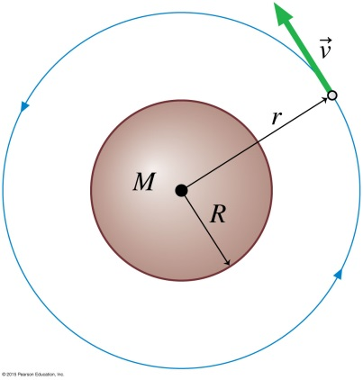Gravitational field/acceleration:

Orbital Velocity:

***Orbital Period:

Orbital Period:

**Rotational Kinematics**

**Oscillations**

**(Where amplitude)**

**(Where amplitude)**

**Collisions**

**Elastic**

* **(Kinetic Energy is Conserved)**

**Perfectly Inelastic**

* **Kinetic energy is lost**

**Explosions**

* **Kinetic energy is gained**

**Waves**

Velocity of a Wave in a String:

* Linear Density:

Doppler Effect:

* I strongly recommend that you **do not** take to time to memorize this. But rather, just understand that if the observer and source are approaching each other, the frequency increases and if they are going away from each other, the frequency is decreasing.