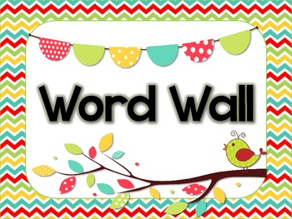
 | First Grade Word Wall Words
about | ever | jump | or | under
after | every | just | our | until
all | family | keep | out | us
also | father | kind | over | use
any | first | knew | park | very
are | food | know | party | want
as | for | last | pet | was
ask | friend | let | play | went
because | from | little | put | were
bed | get | looked | quick | what
best | girl | made | quit | when
big | give | make | ran | where
book | going | man | read | who
boy | good | many | ride | why
but | got | mother | right | will
by | had | name | run | with
came | happy | need | said | would
can't | has | new | saw | yes
car | her | next | school | yet
cat | him | nice | she | you
could | his | night | some | your
day | home | not | take | zoo
did | how | now | that
didn't | if | of | them
dog | I'm | off | then
down | into | old | there
eat | it's | once | they
end | I've | one | this

