**Pathfinder to PrepSTEP: Preparing to take the ASVAB**

1. To get there: **fortbendisd.com /Schools / Ridge Point High School/Library Media Services**



1. Under “**Most Popular RPHS Links”,** click the **PrepSTEP** link:

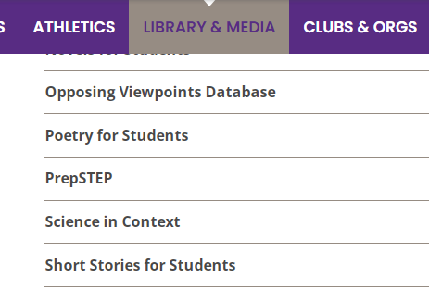

1. Returning users sign in. New users register with email.

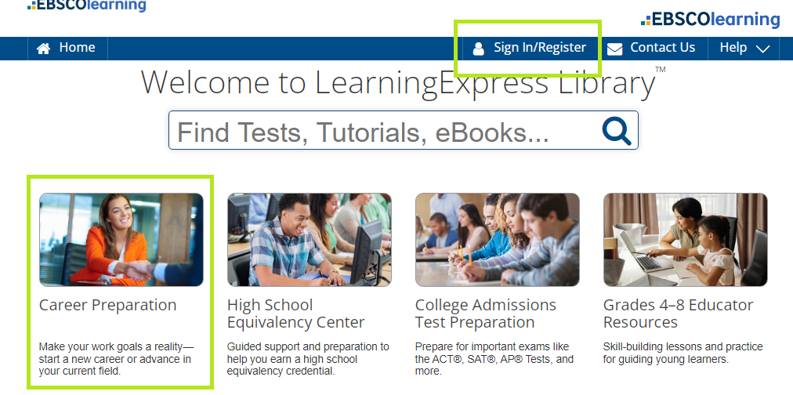

First time users: **REGISTER** using your school email and set your password.

Returning Users: This will be the **Login** each time you access PrepSTEP.

1. Select the tile labeled **Career Center Plus**. Then **Prepare for Military Exams**.



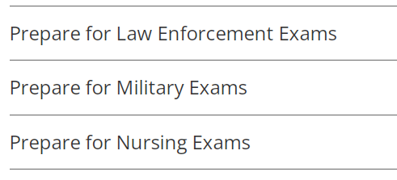

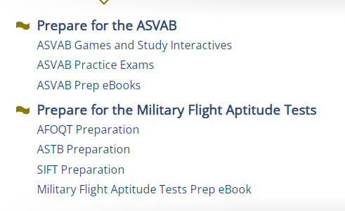

Scan QR code to go directly to resource using camera enabled device.

* Select Fort Bend ISD from the dropdown menu
* Password: **3duc*t3**

