STAAR Practice tests in the Cambium System

www.texasassessment.gov

Student and Families
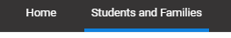

Scroll down to How to Help Prepare Your Child
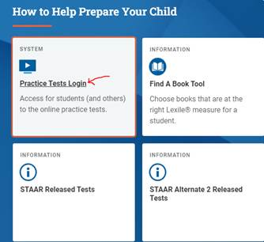

Practice Online Test Login. Just click sign in at the bottom ONLY
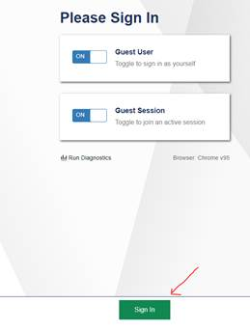
Select Grade Level and Test

Overview of the Test Site for the Texas Assessment Program
Sample Test Page
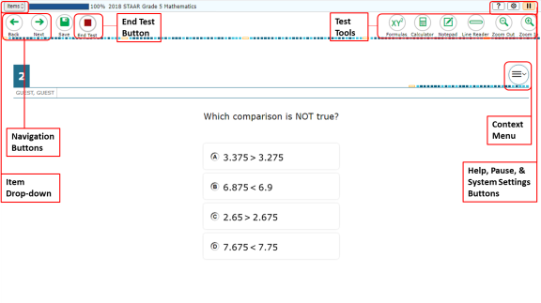
There are two types of test tools available:
- Global Tools: These tools appear in the global menu at the top of the test page.
- Context Menu Tools: These tools are for passages and questions. To use these tools, click the context menu .
Global Tools | Instructions
Help button | To view the on-screen window, select the question mark button in the upper-right corner.
Calculator | To use the on-screen calculator, select Calculator in the global menu.  The calculator may be basic, scientific, or graphing based on the test and provided accommodation  The calculator tool is available for the following tests:  - Texas Instruments Basic: Mathematics Grades 3 – 7, and Science Grade 5  - Texas Instruments Scientific and Texas Instruments Basic: Science Grade 8, and Biology  - Texas Instruments Graphing and Desmos Graphing: Mathematics Grades 8, Algebra I
Dictionary | To search the Merriam-Webster dictionary or thesaurus, select Dictionary in the global menu.
Line Reader | To highlight an individual line of text in a passage or question, select Line Reader in the global menu.  If the enhanced line reader mode is enabled, all content except for the line in focus is grayed out for greater emphasis.  This tool is not available while the Highlighter tool is in use.
Notepad   | To enter notes in an on-screen notepad, select Notes in the global menu.
Periodic Table   | To view the on-screen periodic table, select Periodic Table in the global menu.
System Settings | To adjust audio volume during the test, select the cog wheel icon in the upper-right corner.
Zoom buttons   | To enlarge the text and images on a test page, select Zoom In. Multiple zoom levels are available. To undo zooming, select Zoom Out.

Context Menu Tools | Instructions
American Sign Language | You can watch videos that translate test content into American Sign Language (ASL). To view ASL videos:  - From the context menu, select American Sign Language.  - If only one ASL video is available, the video opens automatically.  - If multiple ASL videos are available, sign language icons appear next to the test content for each video. Select the icon for the test content you wish to translate into ASL.  Note: This tool requires you to have the ASL accommodation turned on.
Highlighter | To highlight text, select the text on the screen and then select Highlight Selection from the context menu. If multiple color options are available, select an option from the list of colors that appears.  To remove highlighting, select Reset Highlighting from the context menu.  You cannot highlight text in images.
Mark for Review | To mark a question for review, select Mark for Review from the context menu. The question number displays a flap in the upper-right corner, like this: ; and a [Flag] icon appears next to the number. The Items drop-down list displays for the selected question.
Strikethrough | For multiple choice and multi-select questions, you can cross out an answer option to focus on the options you think might be correct.  There are two options for using this tool:  Option A:  - To activate Strikethrough mode, open the context menu and select Strikethrough.  - Select the answer options you wish to strike out.  - To deactivate Strikethrough mode, press the Esc key or click outside the response area.  Option B:  - Right-click an answer option and select Strikethrough.
Sticky Notes | To enter notes or comments for a question, select Sticky Notes from the context menu. After you enter a note, a pencil icon appears next to the question number on the test page.  You can only access your notes for a question on that question’s test page.
Text-to-Speech | To listen to passages and questions, select a Speak option from the context menu.
Tutorial | To view a short video demonstrating how to respond to a particular question type, select Tutorial from the context menu.
In addition to the global tools and context menu tools, there are some additional tools that may be available to you based on your test settings.
Other Tools | Description
Content and Language Supports | If you have content and language supports enabled, you can view reference materials and alternate resources that are provided by default based on the item content:  - Rollover: Allows you to view alternate materials. To view the alternate resources, select above the item text to expand the section and view the content. To collapse the expanded section, select .  - Popups: Allows you to view an explanation or definition of specific words or phrases. To open the popup, select a word or phrase that has a border around it. If the TTS feature is enabled, you can select the TTS icon in the popup to listen to the content. While the text is being read aloud, the TTS icon is replaced by the speaking icon.
Expandable Items | When the screen is divided vertically, test questions (items) can be expanded to cover the width of the whole screen. When used in conjunction with the Expandable Passages universal tool—that is, Expandable Passages is not turned off by the test examiner—this tool can be used to expand either passages or questions.  - To expand the passage section, select the right arrow icon [] below the global menu. To collapse the expanded passage section, select the left arrow icon [] in the upper-right corner.  - To expand the question section, select the left arrow icon [] below the global menu. To collapse the expanded question section, select the right arrow icon [] in the upper-left corner.  Expandable Item arrow icons can also be used when the screen is divided horizontally to expand an item [] or collapse the expanded item []. The arrow icons will be on the right side of the screen.
Expandable Passages | When the screen is divided vertically, students can expand and contract the passage in the left pane to cover the width of the whole screen.  - To expand the passage section, select the right arrow icon [] below the global menu. To collapse the expanded passage section, select the left arrow icon [] in the upper-right corner.  Expandable Passage arrow icons can also be used when the screen is divided horizontally to expand a passage [] or collapse the expanded passage []. The arrow icons will be on the right side of the screen.
Speech-to-Text (STT) | If you have the appropriate test setting, you can dictate responses to constructed-response items. To use Speech-to-Text, select the microphone icon in the formatting toolbar above the item response area and begin speaking. The dictated response will be transcribed as text in the item response area.

Test Rules for the Texas Assessment Program

Navigation Rules
- You can skip questions on any test. If a question is skipped, a pop-up window will appear alerting you that you have not entered a response. If you wish to continue, click the Yes button. You can mark a question for review and go back to it later to add or change the answer.
  - Some pages contain multiple questions grouped together. You may need to use the scroll bar to view all the questions.
- You can navigate to test pages by selecting the Back and Next buttons or by selecting an option from the Items drop-down list in the upper-left corner.
- You must submit the test after you finish the test.

Pause Rules
- You can pause the test at any time.
  - If the test is paused for less than 8 hours, you can review questions you already answered.
  - If the test is paused for more than 8 hours, you cannot review questions you already answered. The only exception is if you pause on a page that has at least one unanswered question.
- When you resume the test, the first page with unanswered questions appears.
- If you are idle for 20 minutes, the test automatically pauses and logs you out.
- All answers are saved immediately. You do not lose them when the test is paused.

About Text-to-Speech and Auto Text-to-Speech

About Text-to-Speech
If you are testing with Text-to-Speech, you can listen to instructions, passages, and questions in the test. For Reading tests, some passages are not read aloud.
To listen to content with the Text-to-Speech tool:
- To listen to a passage, open the passage context menu and select Speak Passage. You can also select a portion of text to listen to, such as a word or phrase. To do this, select the text, open the context menu, and select Speak Selection.
- To listen to a question or answer options, open the question context menu and select one of the following Speak options:
  - To listen to a question and its answer options, select Speak Question.
  - To listen only to an answer option, select Speak Option from the context menu and then select the answer option. You can also right-click on the answer option and select Speak Option.

About Auto Text-to-Speech
If you are testing with Auto Text-to-Speech, you can listen to questions in the test. When enabled, text will automatically be read aloud. A student must allow the item to be ready completely before moving to the next test question. For Reading tests, some passages are not read aloud.

